International Standards
# Source: AI Source: Provided by: [Data Path: Persons Table -> ID Column: 1, Name_En Column: Motasem Essam] -> From: [ChatGPT] on [7/17/2026]
International Standards are the highest-level measurement standards recognized worldwide. They define and preserve the values of measurement units through international agreement, ensuring that measurements made in different countries are accurate, consistent, comparable, and traceable.
These standards form the top of the global measurement hierarchy and provide the reference for all national, primary, secondary, and working standards.

Definition
# Source: AI Source: Provided by: [Data Path: Persons Table -> ID Column: 1, Name_En Column: Motasem Essam] -> From: [ChatGPT] on [7/17/2026]
An International Standard is a measurement standard that is recognized by international agreement and serves as the ultimate worldwide reference for a measurement unit.
It provides the highest level of measurement consistency and is used as the basis for establishing national measurement standards.

Purpose
# Source: AI Source: Provided by: [Data Path: Persons Table -> ID Column: 1, Name_En Column: Motasem Essam] -> From: [ChatGPT] on [7/17/2026]
International standards are designed to:
- Define internationally accepted measurement units.
- Ensure worldwide uniformity of measurements.
- Support international trade.
- Enable scientific collaboration.
- Provide traceability for national standards.
- Maintain long-term measurement stability.

Characteristics
# Source: AI Source: Provided by: [Data Path: Persons Table -> ID Column: 1, Name_En Column: Motasem Essam] -> From: [ChatGPT] on [7/17/2026]
International standards are:
- Internationally recognized.
- Highly accurate.
- Stable over long periods.
- Maintained through international cooperation.
- Traceable to fundamental physical constants or agreed definitions.
- Used as the highest reference level.

Position in the Measurement Hierarchy
# Source: AI Source: Provided by: [Data Path: Persons Table -> ID Column: 1, Name_En Column: Motasem Essam] -> From: [ChatGPT] on [7/17/2026]
International standards occupy the highest position in the calibration chain.
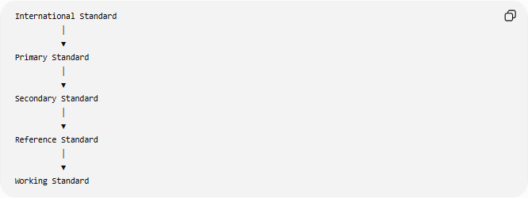
International Standard
│
▼
Primary Standard
│
▼
Secondary Standard
│
▼
Reference Standard
│
▼
Working Standard

Who Maintains International Standards?
# Source: AI Source: Provided by: [Data Path: Persons Table -> ID Column: 1, Name_En Column: Motasem Essam] -> From: [ChatGPT] on [7/17/2026]
International standards are maintained through international metrology organizations.
International Bureau of Weights and Measures (BIPM)
The International Bureau of Weights and Measures (BIPM) coordinates worldwide measurement standards and maintains the International System of Units (SI).
Responsibilities include:
- Maintaining international references.
- Coordinating comparisons between countries.
- Supporting global measurement consistency.

General Conference on Weights and Measures (CGPM)
# Source: AI Source: Provided by: [Data Path: Persons Table -> ID Column: 1, Name_En Column: Motasem Essam] -> From: [ChatGPT] on [7/17/2026]
The CGPM is the international authority that adopts and updates the SI system.
Responsibilities include:
- Approving SI definitions.
- Revising measurement standards.
- Coordinating international measurement policy.

International Committee for Weights and Measures (CIPM)
# Source: AI Source: Provided by: [Data Path: Persons Table -> ID Column: 1, Name_En Column: Motasem Essam] -> From: [ChatGPT] on [7/17/2026]
The CIPM supervises scientific work related to international measurement standards.
Responsibilities include:
- Advising the CGPM.
- Monitoring international comparisons.
- Supporting the BIPM.

Modern International Standards
# Source: AI Source: Provided by: [Data Path: Persons Table -> ID Column: 1, Name_En Column: Motasem Essam] -> From: [ChatGPT] on [7/17/2026]
Modern international standards are no longer based primarily on physical artifacts. Instead, they are defined using fundamental constants of nature, making them more stable and universally reproducible.
Examples include:
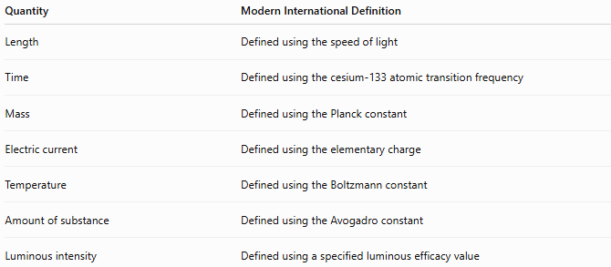
Quantity | Modern International Definition
Length | Defined using the speed of light
Time | Defined using the cesium-133 atomic transition frequency
Mass | Defined using the Planck constant
Electric current | Defined using the elementary charge
Temperature | Defined using the Boltzmann constant
Amount of substance | Defined using the Avogadro constant
Luminous intensity | Defined using a specified luminous efficacy value

Examples of International Standards
# Source: AI Source: Provided by: [Data Path: Persons Table -> ID Column: 1, Name_En Column: Motasem Essam] -> From: [ChatGPT] on [7/17/2026]
Length
The meter is internationally defined as:
The distance traveled by light in a vacuum during 1/299,792,458 of a second.

Time
The second is defined as:
The duration of 9,192,631,770 periods of the radiation corresponding to the transition between two hyperfine energy levels of the ground state of the cesium-133 atom.

Mass
Since 2019, the kilogram has been defined by fixing the numerical value of the Planck constant, replacing the former platinum-iridium prototype.

Functions of International Standards
# Source: AI Source: Provided by: [Data Path: Persons Table -> ID Column: 1, Name_En Column: Motasem Essam] -> From: [ChatGPT] on [7/17/2026]
International standards are used to:
- Define SI units.
- Establish national primary standards.
- Support calibration laboratories.
- Ensure measurement traceability.
- Maintain worldwide consistency.
- Facilitate scientific research.

Traceability
# Source: AI Source: Provided by: [Data Path: Persons Table -> ID Column: 1, Name_En Column: Motasem Essam] -> From: [ChatGPT] on [7/17/2026]
Every accurate measurement should be traceable to an international standard through an uninterrupted chain of calibrations.
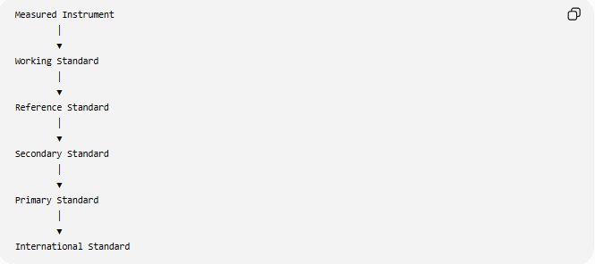
Measured Instrument
│
▼
Working Standard
│
▼
Reference Standard
│
▼
Secondary Standard
│
▼
Primary Standard
│
▼
International Standard

Advantages
# Source: AI Source: Provided by: [Data Path: Persons Table -> ID Column: 1, Name_En Column: Motasem Essam] -> From: [ChatGPT] on [7/17/2026]
International standards:
- Ensure worldwide measurement consistency.
- Improve scientific accuracy.
- Support international commerce.
- Reduce measurement uncertainty.
- Enable reliable calibration.
- Remain stable over long periods.

Applications
# Source: AI Source: Provided by: [Data Path: Persons Table -> ID Column: 1, Name_En Column: Motasem Essam] -> From: [ChatGPT] on [7/17/2026]
International standards are essential in:
- Scientific research
- Engineering
- Manufacturing
- Aerospace
- Medicine
- Telecommunications
- Navigation
- International trade
- Calibration laboratories
- National metrology institutes

Everyday Examples
# Source: AI Source: Provided by: [Data Path: Persons Table -> ID Column: 1, Name_En Column: Motasem Essam] -> From: [ChatGPT] on [7/17/2026]
Although people rarely interact with international standards directly, they affect everyday life through:
- Accurate fuel pumps.
- Correct grocery scales.
- Reliable thermometers.
- GPS positioning.
- Medical equipment calibration.
- Manufacturing precision.
- Fair commercial transactions.

Common Mistakes
# Source: AI Source: Provided by: [Data Path: Persons Table -> ID Column: 1, Name_En Column: Motasem Essam] -> From: [ChatGPT] on [7/17/2026]
- Confusing international standards with SI units. (SI units are defined by international standards, but they are not the standards themselves.)
- Assuming international standards are still physical objects. (Most modern standards are based on physical constants.)
- Confusing international standards with national standards.

Key Points
# Source: AI Source: Provided by: [Data Path: Persons Table -> ID Column: 1, Name_En Column: Motasem Essam] -> From: [ChatGPT] on [7/17/2026]
- International standards are the highest-level measurement standards.
- They define measurement units recognized worldwide.
- They provide the reference for all lower-level standards.
- They are maintained through international metrology organizations.
- Modern international standards are based on fundamental physical constants rather than physical artifacts.

International Standards vs. Primary Standards
# Source: AI Source: Provided by: [Data Path: Persons Table -> ID Column: 1, Name_En Column: Motasem Essam] -> From: [ChatGPT] on [7/17/2026]
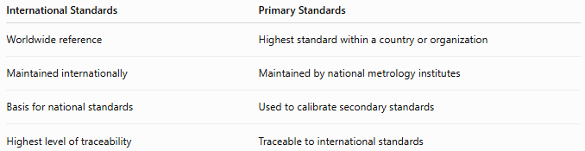
International Standards | Primary Standards
Worldwide reference | Highest standard within a country or organization
Maintained internationally | Maintained by national metrology institutes
Basis for national standards | Used to calibrate secondary standards
Highest level of traceability | Traceable to international standards

International Standards vs. National Standards
# Source: AI Source: Provided by: [Data Path: Persons Table -> ID Column: 1, Name_En Column: Motasem Essam] -> From: [ChatGPT] on [7/17/2026]
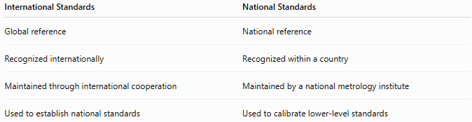
International Standards | National Standards
Global reference | National reference
Recognized internationally | Recognized within a country
Maintained through international cooperation | Maintained by a national metrology institute
Used to establish national standards | Used to calibrate lower-level standards

Conclusion
# Source: AI Source: Provided by: [Data Path: Persons Table -> ID Column: 1, Name_En Column: Motasem Essam] -> From: [ChatGPT] on [7/17/2026]
International Standards are the highest-level measurement standards recognized by international agreement. They provide the definitive reference for measurement units and ensure that measurements made anywhere in the world are accurate, consistent, and traceable. Maintained through organizations such as the BIPM, CGPM, and CIPM, modern international standards are based on fundamental physical constants, providing long-term stability and supporting science, engineering, industry, healthcare, and global commerce.

